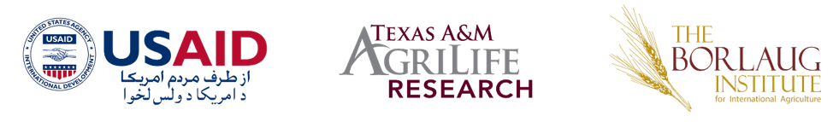

Women’s Scholarship Endowment (WSE)

About WSE Program
The Women’s Scholarship Endowment (WSE) Activity aims to assist Afghan women obtain a university education in a field of Science, Technology, Engineering, or Mathematics (STEM), so that they may overcome barriers to employment, raising their incomes, and in developing leadership roles within their families, communities, and in both public and private sector organizations.
WSE provides scholarships for tuition and student stipend. Students attending any private or public university in Afghanistan are eligible to apply.

Eligibility
In order to receive this scholarship, a candidate must meet the basic eligibility requirements outlined below. An applicant must:
- Be female
- Be an Afghan National
- Have been accepted to a public or private university in Afghanistan or regional University to study a STEM or STEM related major
- New students who have yet to receive an acceptance letter are eligible to apply. They must indicate in their application they are awaiting acceptance. If an applicant is selected for a scholarship, she must produce the acceptance letter prior to receiving the scholarship. If she is unable to show proof of acceptance prior to the start of the academic year, she will be in the waiting list for the next round of scholarships.
- Not be on academic or disciplinary probation
- Meet the below grade requirements
  - New Undergraduate Student: Have a minimum cumulative grade of 75% from her high school studies ((نمرات سه ساله.
  - Existing Undergraduate Student: Have a minimum cumulative grade of 80% on a percentage scale or 3.0 CGPA on a 4.0 scale from her undergraduate university studies. Engineering students with a cumulative grade of 75% on a percentage scale or 2.7 Cumulative Grade Point Average (CGPA) on a 4.0 scale are eligible.
  - New Graduate Student: Have a minimum cumulative grade of 80% on a percentage scale or 3.0 CGPA on a 4.0 scale from their undergraduate university studies.
  - Existing Graduate Student: Have a minimum cumulative grade of 80% on a percentage scale or 3.0 CGPA on a 4.0 scale from their graduate studies.

How to Apply
Interested individuals should follow the below steps to apply for the WSE Scholarship.

- Apply online: https://smr.to/p68135

- Download the application form from main page of following universities: (Kardan University, Gawharshad University, Bakhtar University, Ghalib University, Rana University, American University of Afghanistan, Moora Educational Complex, Jami University, Khatam Al-Nabieen University, Kateb University, and Afghanistan Center at Kabul University)

- You can alternatively get hard copy of the application forms from above universities, and Afghanistan Center at Kabul University
- Complete your application package. Due to the volume of applications expected, any application package missing required documentation or information may not be evaluated. So, please ensure your application package is complete when you submit it. As outlined on the application form, a completed application package will include:
- Complete Application Form
- Statement of Purpose and Objectives Letter
- Two (2) Letters of recommendation
- Photo ID – Passport or Tazkira
- Acceptance letter to university/program
- Official transcript from High School (three years), Undergraduate or Graduate program transcripts
- English Proficiency Certificate if available (recommended for graduate students)
Applicants must submit their completed scholarship application package no later than October 18, 2020. Application may be submitted via email to wse.applications@ag.tamu.edu or through online link: https://smr.to/p68135

- Or alternatively in person at (Kardan University, Gawharshad University, Bakhtar University, Ghalib University, Rana University, American University of Afghanistan, Moora Educational Complex, Jami University, Khatam Al-Nabieen University, Kateb University, and Afghanistan Center at Kabul University)
- Applicants in provinces can submit hard copies of applications to the Lincoln Centers in their provinces.

Evaluation Criteria
Applications will initially be reviewed for completeness. Incomplete applications will not be evaluated. Completed applications will be evaluated on the following criteria:
- Academic performance
- Statement of Purpose and Objective Letter
- Letters of Recommendation
- Involvement in extra-curricular (non-academic) activities
- Preference will be shown to women studying a field in science, technology, engineering, or math (STEM) over those studying a STEM related topic.
- Applicants from rural areas are encouraged to apply.
Once applications have been evaluated, the top candidates will be invited to interview. Interviews will be evaluated on the following criteria:
- Self-Presentation, confidence, professionalism
- Enthusiasm, motivation and commitment to a career in STEM
- Interpersonal and communication skills
- English Proficiency (graduate students only)

